GEO892 (Section 001), Fall 2017, 3 credits; Tu & Th 5:00-6:20 pm; Geography 126
Micrometeorological Instrumentation & Measurements
Dr. Jiquan Chen (Geography)
Email: jqchen@msu.edu
Class Webpage: http://lees.geo.msu.edu/courses/Geo892

Schedule
08/31/17 (Lecture #1)
Introduction
Reading: Chen et al. 1999. Bioscience
Temperature and dynamics
Class activities

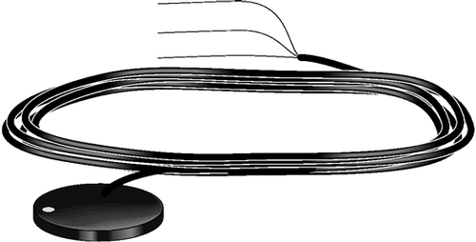
09/05/17 (Lecture #2)
Ohm’s Law
Thermocouple principles (thermopiles) and soil heat flux (HFT3)
Introduction of Loggernet and programing w/ CR10 and CR23

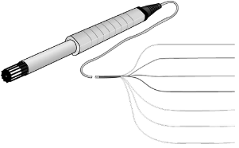
09/07/17 (Lecture #3)
Ta, Tw, Td, relative humidity, vapor pressure, and VPD
Thermistor, IR surface temperature, barometer
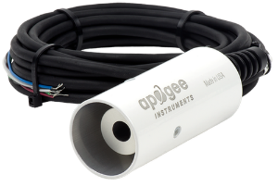
Programming with HMP45C (Ta & RH) and Surface Temperature Sensors in CR23
Homework #1

09/12/17 (Lecture #4)
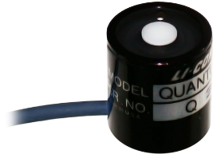
Stefan-Boltzmann Law
Radiation (long and short radiation), albedo, Greenhouse effects
Radiometers (PAR, pyranometer, CNR4, Q7.1) and CR23

09/14/17 (Lecture #5)
Wind speed, wind direction, windrose
Precipitation (TE525)
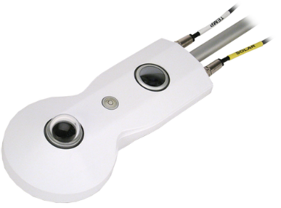
Wind Monitor and CR23
09/21/17 (4:00 – 18:30 h) (Lecture #6-7)
Sensible heat (H), latent heat (L), heat storage, Bowen ratio
ET vs LE, transpiration (sap flow)
Energy Balance (Rn=LE + H +G)
Gradient methods

09/26/17 (4:00 – 18:30 h) (Lecture #8-9)
Development of full weather station
Homework #2: Design, programming, maintenance, and preliminary results

09/28/17 (Lecture #10)
Eddy-covariance method: principles and requirements

10/03/17 (12:00 – 8:00 h) (Lab #1)
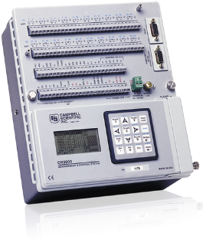
Eddy-covariance (EC) method: principles and requirements (cont.)
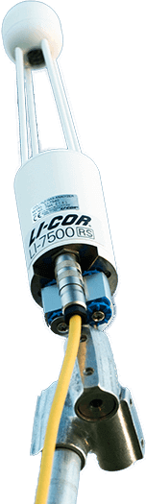
Programming with CRBasic Editor w/ CR5000

10/10/17 (12:00 – 8:00 h) (Lab #2)
Introduction of EC sensors (CSAT3, LI7500)
Design of a complete EC tower
Homework #3: Modeling F_{CO2} and ET (TBD)

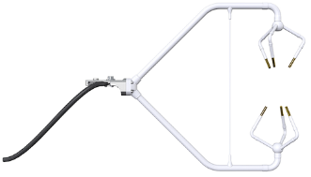
10/20/17 (8:00 -17:00 h) (Lab #3)
Tower installations
Summary and term paper(s)

10/24/17
Term paper & discussion
Maintenance and data (Q&A #1)

10/26/17 (Lecture #11)
Data processing,

11/07/17
Maintenance and data (Q&A #2)

11/14/17
Maintenance and data (Q&A #3)

11/21/17
Maintenance and data (Q&A #4)

12/07/17 (Lecture #12)
Overview
Term paper due on Dec. 14, 2017

