LAB EXERCISE NO. 01 DUE DATE: 9/17/2015
Total Points: 4

TOPIC: Introduction to Digital Image Processing Software – ERDAS Imagine 2014
In this exercise, you are to familiarize one of the major image processing software sets in common use today – ERDAS Imagine. The objectives of this exercise are to: 1) introduce you to this image processing software program, 2) learn about the nature of digital images, 3) perform some basic image processing manipulations (display, zoom, pan and contrast adjustment), 4) perform some fundamental digital image analysis, and 5) learn how to build a model in the ERDAS Imagine environment.

Image Data: There is a Landsat 5 image acquired in Michigan. The image is available in:
C:\Classes\Geo827\Data\Landsat_mi\

There are two files with file names starting with LT50210302001168XXX02… One of them is .MTL file, which contains the needed information while the other is the image itself. This image is a Level 1T product that is radiometrically, geometrically corrected (systematic) and terrain corrected to user-specified parameters including output map projection, image orientation, and pixel size. The correction algorithms model the spacecraft and sensor using data generated by onboard computers during imaging. Sensor, focal plane, and detector alignment information provided by the Image Assessment System (IAS) in the Calibration Parameter File (CPF) is also used to improve the overall geometric fidelity. The resulting product is free from distortions related to the sensor (e.g., jitter, view angle effect), satellite (e.g., attitude deviations from nominal), and Earth (e.g., rotation, curvature). Residual error in the systematic L1T product is less than 250 meters (1 sigma) in flat areas at sea level. The Level 1T (L1T) data product provides systematic radiometric accuracy, geometric accuracy by incorporating ground control points, while also employing a Digital Elevation Model (DEM) for topographic accuracy. Geodetic accuracy of the product depends on the accuracy of the ground control points and the resolution of the DEM used.

PART A: ERDAS Imagine Software
1. Open ERDAS from the icon on the desktop
2. Select the Open File icon in the upper left corner of Erdas and navigate to the “LT50210302001168XXX02” file folder and open the similarly named ‘.img’ file.

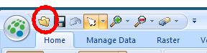

3. You should see a false-color image displayed on the screen (“landsat band combination”: 4,3,2 or NIR, Red, Green)
4. Under “Raster” at the top of the screen, select the “Multispectral” tab and make sure “Landsat 7 Multispectral” is selected from the dropdown menu

PART B: Image Analysis
1. User interface

If you have never used Erdas before, you may actually have an advantage because this version has a whole new interface. It very much resembles Microsoft Office. Take a few minutes to get familiar with it and find some of the basic functions that you will use regularly including:
Zoom In/Out
Pan
“Zoom to Data Extent”
“Fit view to Data Extent”
How to change band combinations

http://web.pdx.edu/~emch/ip1/bandcombinations.html

http://gdsc.nlr.nl/gdsc/en/information/earth_observation/band_combinations

There may be multiple ways to accomplish these tasks so feel free to explore!
2. Image Info

Under the “Home” tab, select “Layer Info”. Examine the following image content and briefly summarize what information each provides:

a) File Information:_______________________________________________________________

b) Layer Information:______________________________________________________________

c) Statistics Information:___________________________________________________________

d) Map Information:_______________________________________________________________

e) Projection Information (record specifics below):_______________________________________
Projection Type:_____________________________________
Spheroid Name:_____________________________________
UTM Zone:_________________________________________
North or South:______________________________________

f) Which one the above (a – e) changes with each layer?

3. Image Statistics
In the ImageInfo window, click on the General and Histogram tabs back and forth to record the following information:
Layer 1: This band records the _______________________ reflectance (name the waveband).
Min. Value____________ Max. Value____________________
Mean Value___________ Std Dev_______________________
Uni- or Bimodal________
Layer 2: This band records the _______________________ reflectance (name the waveband).
Min. Value____________ Max. Value____________________
Mean Value___________ Std Dev_______________________
Uni- or Bimodal________
Layer 3: This band records the _______________________ reflectance (name the waveband).
Min. Value____________ Max. Value____________________
Mean Value___________ Std Dev_______________________
Uni- or Bimodal________
Layer 4: This band records the _______________________ reflectance (name the waveband).
Min. Value____________ Max. Value____________________
Mean Value___________ Std Dev_______________________
Uni- or Bimodal________

Layer 5: This band records the _______________________ reflectance (name the waveband).
Min. Value____________ Max. Value____________________
Mean Value___________ Std Dev_______________________
Layer 5: This band records the _______________________ reflectance (name the waveband).
Min. Value____________ Max. Value____________________
Mean Value___________ Std Dev_______________________
Uni- or Bimodal________

Layer 6 (band 7): This band records the _______________________ reflectance (name the waveband).
Min. Value____________ Max. Value____________________
Mean Value___________ Std Dev_______________________
Uni- or Bimodal________

4. Next, in the ImageInfo window, click on Pixel Data to examine actual data values. Record the pixel values for 6 different locations:

location | Row | Col | B1 | B2 | B3 | B4 | B5 | B6
1
2
3
4
5
6

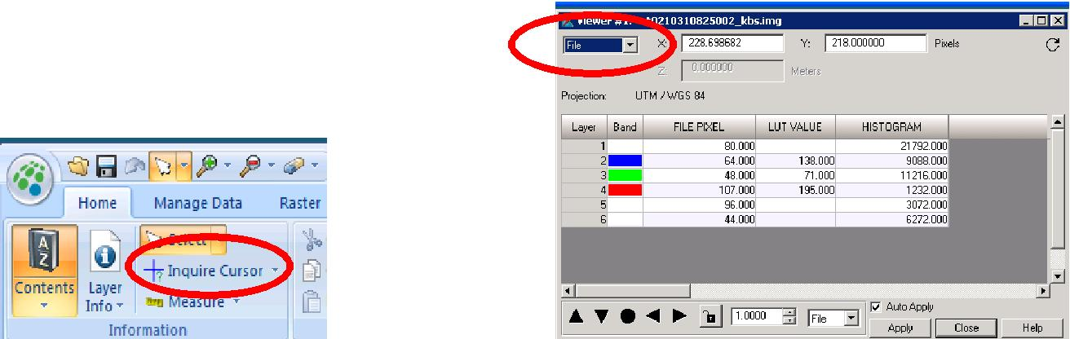

DN
250
200
150
100
50
B1 | B2 | B3 | B4 | B5 | B6

PART C. ERDAS MODELER
1. Under the Toolbox tab, select Model Maker and these windows will pop-up:

2. To build a model you will need to know the following:

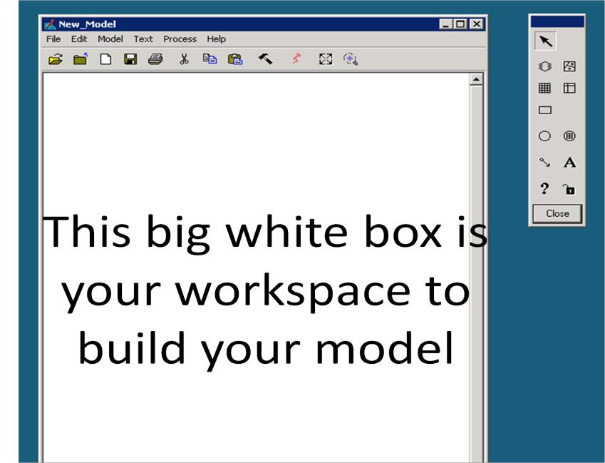

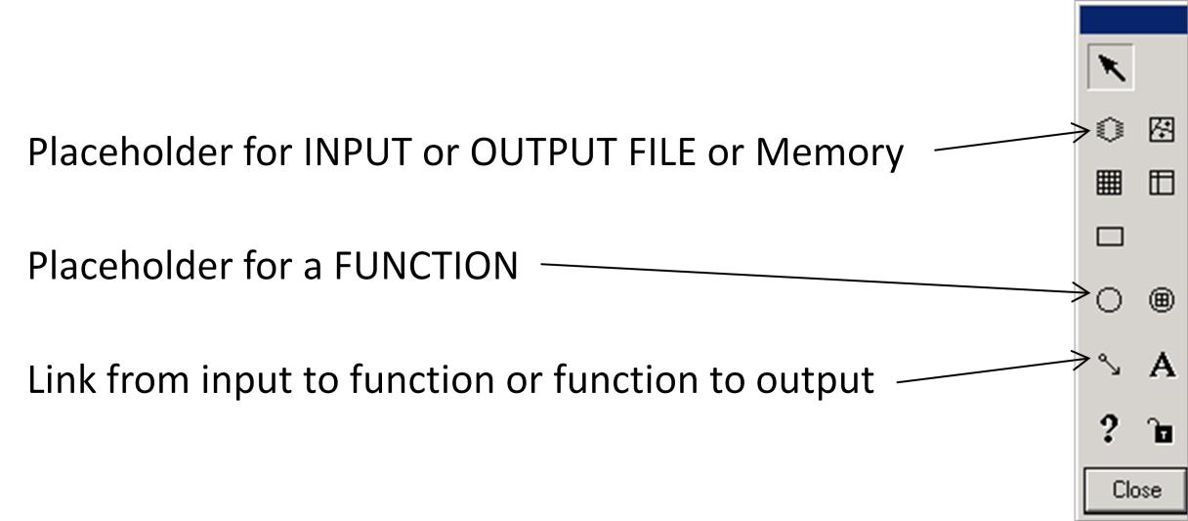

3. Build a simple model:
a. Place an INPUT in your workspace
b. Place a FUNCTION under your INPUT
c. LINK the INPUT to the FUNCTION
d. Double click the INPUT and navigate the “lt50210302001168xxx02.img” file
e. Double click the FUNCTION and you will see all of the layers of the Landsat image in the upper left corner. REMEMBER, although the layers are numbered 1-6, layer 6 is actually band 7.
f. On the right hand side you will see a dropdown menu of functions and mathematical operations for each function below. Look through the functions and see if you can find the “STACK LAYERS” operation (it is NOT a function), which we will use later.
g. Once you have searched through the functions, choose select any band from the image and multiply it by 1.5 and subtract 20. This is a linear transformation with a slope of 1.5 and an intercept of -20.
h. Now place an OUTPUT in the workspace and link the FUNCTION you just created to the output.
i. Double click the OUTPUT and choose a name for the file and save it in your own directory (think about the output file type here).
j. Check the box that says “Delete if Exists”
k. You can label each portion of the model by selecting the “A” on the modeler menu (optional).
l. Save your model in your own directory from the workspace menu and close out of the modeler.
m. Start the modeler up again and navigate to your model. To run it, click on the red lightning bolt.
n. Attach a screenshot of your model to your lab report.

4. Downloading landsat scenes from glovis.usgs.gov

- Using GloVis to find and download Landsat scenes

- Go to http://glovis.usgs.gov/

- Use the dropdown menus and choose Landsat Archive and the specific Landsat satellite (L4, L5, L7 or L8).

- Click on your general study area on the world map and navigate to the scene (or type in specific coordinates).

To select a landsat scene you want to download, a viewer will appear in a separate window (please make sure you have the latest java runtime installed and check if your browser’s pop-up blocker is disabled). To orient yourself, choose Map Layers from the menu at the top of the window and select to view Cities, Roads, etc and overlay them on the scenes. You can use the Prev Scene and Next Scene buttons to find images of the year and month and month of interest (it helps to know the local growing season in order to find cloud-free image). Move the arrow buttons to in order to get to to the scenes in the path/row adjacent to the highlighted scene.

- Highlight your selected image by clicking on it, and then Add in the lower left corner of the viewer.
- Download and confirm. Then, submit. The Landsat scene shows up in a shopping basket where you double-check and submit order.

